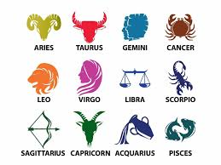
Chatterbox Episode #101 – What’s your personality?
The two women speaking in this podcast episode are Maura and Harp. Listen as they talk about personalities.

- What is Harp’s zodiac sign? _____________________________________________________________
- What positive personality characteristics does she say are associated with this sign? ________________________________________________________________________________________________________________________________________________________________________
- Harp also mentions two negative personality traits for this zodiac sign. What are they? ________________________________________________________________________________________________________________________________________________________________________
- What is Maura’s zodiac sign? ____________________________________________________________
- What positive personality characteristics does she say are associated with this sign? ________________________________________________________________________________________________________________________________________________________________________
- What are the negative traits associated with this sign? ________________________________________________________________________________________________________________________________________________________________________
- After the women discuss zodiac signs, they start talking about blood type. Where does one of the woman say she first learned about blood type being a predictor of one’s personality? ____________________________________________________________________________________
- What personality traits are associated with having Type A blood? ________________________________________________________________________________________________________________________________________________________________________
- What personality traits are associated with having Type B blood? ________________________________________________________________________________________________________________________________________________________________________
- What personality traits are associated with having Type O blood? ________________________________________________________________________________________________________________________________________________________________________
- What personality traits are associated with having Type AB blood? ________________________________________________________________________________________________________________________________________________________________________

