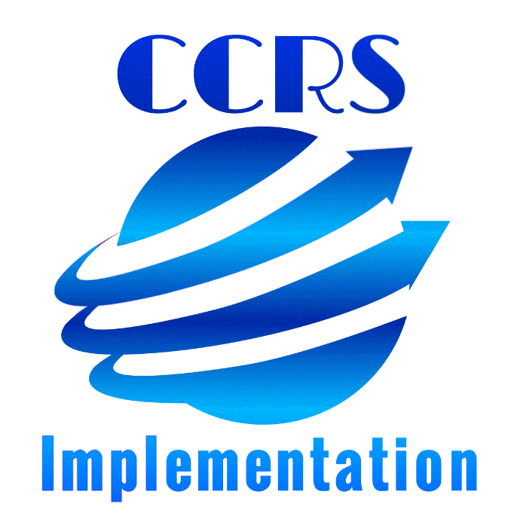

Program CCRS Implementation Plan

Overview
Led by an administrator, at the close of this cohort year each program will have a plan to expand these key components of standards implementation beyond the cohort participants.

- Lay the groundwork for standards implementation:
  - Identify the benefits of standards-based education
  - Clearly communicate standards implementation processes and plans
  - Develop staff’s foundational understanding of the standards

- Identify and access supports for standards implementation (PD, funding, instructional resources, other programs, etc.)
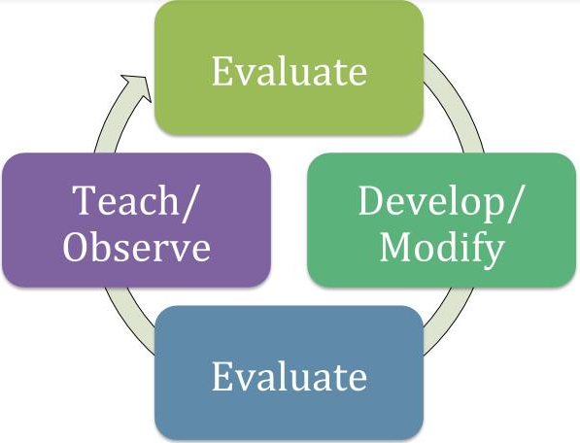
- Improve instructional quality:
  - Identify appropriate standards for a particular class level or student learning plan
  - Evaluate lessons/units to determine alignment and make needed improvements (Resource Alignment Evaluation and Rating Tool & High-Value Action Tool)
  - Create standards-aligned lessons/units (Lesson/Unit Planning Template)
  - Evaluate larger resources (such as curricula or textbooks) to determine alignment and needed modifications (Resource Alignment Evaluation and Rating Tool & High-Value Action Tool)
  - Observe & provide feedback to instructors regarding standards-aligned instruction (Observation Tool)

- Develop and modify program structures to support standards implementation (class offerings with well-articulated standards objectives, student placement, staffing, etc.)

Program Plan

Component 1: Groundwork

1. Lay the groundwork for standards implementation:
  - Identify the benefits of standards-based education
  - Clearly communicate standards implementation processes and plans
  - Develop staff’s foundational understanding of the standards
Questions for Consideration:
- What is our key message around CCRS implementation?
- What strategies will we use to gain the support of key individuals or stakeholders?
- What challenges have we faced with implementing previous initiatives and how have we successfully overcome them?
- What barriers do we anticipate and how might you handle them?
- How will we support staff who are hesitant to change?
- What professional development and other activities can support teachers’ understanding and implementation of the key instructional shifts in math and ELA? (rigor, focus, coherence; text complexity, evidence, knowledge)

Notes/Questions:

Use the template below to identify objectives and action items that will support the implementation of this component. Add objectives as needed.
Measurable Objective:
Action Item | Time Frame | Person Responsible | Resources Needed
Expected Outcome (What will it look like when we have succeeded with this objective?):

Component 2: Supports

2. Identify and access supports for standards implementation (PD, funding, instructional resources, other programs, etc.)

Questions for Consideration:
- What funding is available or could be reallocated to support standards training and implementation?
- How will our cohort participants be leaders in future standards training and/or implementation activities in our program?
- What incentives can be provided to staff for participation?
- What expertise do we currently have on staff or within the district or area?
- What local PD structures are currently in place that could be repurposed (e.g. staff meetings, PLCs, etc.)?

Notes/Questions:

Use the template below to identify objectives and action items that will support the implementation of this component. Add objectives as needed.
Measurable Objective:
Action Item | Time Frame | Person Responsible | Resources Needed
Expected Outcome (What will it look like when we have succeeded with this objective?):

Component 3: Instructional Quality

3. a. Identify appropriate standards for a particular class level or student learning plan

Questions for Consideration:
- How will work as a team to determine which standards will be addressed in different aspects of our programming?
- How will we determine priority standards for our program or individual students?
- How is this being documented and shared in our program and with students?
- How will we revisit and refine these decisions as needed moving forward?

Notes/Questions:

Use the template below to identify objectives and action items that will support the implementation of this component. Add objectives as needed.
Measurable Objective:
Action Item | Time Frame | Person Responsible | Resources Needed
Expected Outcome (What will it look like when we have succeeded with this objective?):

3. b. Evaluate lessons/units to determine alignment and make needed improvements (Resource Alignment Evaluation and Rating Tool & High-Value Action Tool)

Questions for Consideration:
- Will staff work individually or collaboratively on the lesson/unit evaluation process? Will all staff be responsible for evaluating lessons and units or just a key team?
- How will revised lessons/units be shared within our program?
- How will staff be supported or compensated for this evaluation and revision process?

Notes/Questions:

Use the template below to identify objectives and action items that will support the implementation of this component. Add objectives as needed.
Measurable Objective:
Action Item | Time Frame | Person Responsible | Resources Needed
Expected Outcome (What will it look like when we have succeeded with this objective?):

3.c. Create standards-aligned lessons/units (Lesson/Unit Planning Template)

Questions for Consideration:
- What lesson/unit planning templates will be used in our program? [if using something in addition to the CCRS cohort provided templates]
- How will staff be trained to use the lesson/unit planning templates?
- Who will create aligned lessons and units? Will all teachers work to create and vet their own, or will a team work to create and/or vet lessons?
- How will staff work together to assure that created lessons are high-quality and standards-aligned?
- How will lessons/units be shared within our program?

Notes/Questions:

Use the template below to identify objectives and action items that will support the implementation of this component. Add objectives as needed.
Measurable Objective:
Action Item | Time Frame | Person Responsible | Resources Needed
Expected Outcome (What will it look like when we have succeeded with this objective?):

3.d. Evaluate larger resources (such as curricula or textbooks) to determine alignment and needed modifications (Resource Alignment Evaluation and Rating Tool & High-Value Action Tool)

Questions for Consideration:
- What will be the process for evaluating and supplementing existing resources? Who will be involved?
- How will decisions be made about discontinuing the use of resources/curricula/textbooks that lack sufficient alignment?
- What will be the process for evaluating resources to be purchased? Who will be involved?
- How will these larger aligned resources be shared within our program?

Notes/Questions:

Use the template below to identify objectives and action items that will support the implementation of this component. Add objectives as needed.
Measurable Objective:
Action Item | Time Frame | Person Responsible | Resources Needed
Expected Outcome (What will it look like when we have succeeded with this objective?):

3. e. Observe & provide feedback to instructors regarding standards-aligned instruction (Observation Tool)

Questions for Consideration:
- What are our current policies and procedures around observation? How might those be modified or supplemented to support standards-based observations and feedback?
- How will additional staff in our program be trained to use the Shift-based CCRS Observation Form and/or the full CCRS Observation Form?
- How might peer observations be used to support professional development around standards?
- What supports (training, release time, subs, etc.) will need to be put in place for observations?

Notes/Questions:

Use the template below to identify objectives and action items that will support the implementation of this component. Add objectives as needed.
Measurable Objective:
Action Item | Time Frame | Person Responsible | Resources Needed
Expected Outcome (What will it look like when we have succeeded with this objective?):

Component 4: Program Structures

4. Develop and modify program structures to support standards implementation (class offerings with well-articulated standards objectives, student placement, staffing, etc.)

Questions for Consideration:
- How will our program staff work together to determine gaps in offerings around the standards?
- How will decisions be made to grow or alter current course offerings to ensure standards implementation?
- How might our student assessment and/or placement procedures need to change?
- How might staffing decisions be impacted by standards-implementation work?
- How can volunteers get the information they need to support standards-based instruction, and how can they best be used in our program?

Notes/Questions:

Use the template below to identify objectives and action items that will support the implementation of this component. Add objectives as needed.
Measurable Objective:
Action Item | Time Frame | Person Responsible | Resources Needed
Expected Outcome (What will it look like when we have succeeded with this objective?):

