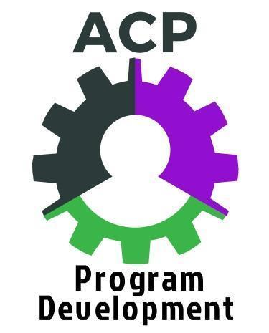
SMART Goal – ENGAGING EMPLOYERS IN ACP PROGRAMMING

STEPS:
- Write and hone your goal.
- Get feedback from colleagues and in particular your ACP cohort partner.
- Revise accordingly.
- Consider potential obstacles and how to address them.
- Set action steps.
- Take action.
- Reflect on the results. Plan next action steps.
- Be ready to talk about steps taken and progress toward goals during cohort check-in calls and at the May 2018 wrap-up workshop.

ACP area of focus – ENGAGING EMPLOYERS IN ACP PROGRAMMING

- Look through all the work you have done in Assignment #8A and Assignment #8B and notes from the webinar to help inform and shape a high-priority, high-impact goal to engage new employers or engage current employer partners in new ways.
- Review the Setting SMART Goals document from our August training for a reminder about effective SMART goals.
- Exchange drafts with your cohort peer partner and give each other feedback – is the goal specific/clear, measurable, achievable, relevant and time-based? How could it be strengthened?

Initial idea for a goal:

Now hone the goal using SMART principles. Use the Setting SMART Goals guide to help.

1. Specific (What exactly do you want to accomplish? Who needs to be included? When do you want to do this?)

2. Measurable (What can be clearly measured in your goal? How can you measure progress; what would indicate that you’ve successfully met your goal?)

3. Achievable (Do you have the skills and resources required to achieve the goal? If not, can you obtain them? What is the motivation for this goal? Is the amount of effort required on par with the value if the goal is achieved?)

4. Relevant (Why is this a goal? Why is it significant? What are the benefits if achieved? Why now? Is it aligned with the objectives of the ACP cohort and my ACP program?)

5. Time-based (When will you achieve this goal? What’s a realistic deadline?)

S.M.A.R.T. Goal (Review what you have written, and craft a new unified goal statement in 1 or 2 sentences.)

Identify possible obstacles and potential solutions

Possible obstacles | Potential solutions

Plan Action Steps

Step | By (date) | Results / reflection

Report and Reflect on SMART Goal
(near end of cohort year)

- Was the goal accomplished? In full? In part?

- Reasons for success?

- Difficulties encountered that hindered accomplishing the goal?

- Implications for moving forward?

- Next SMART goal for this area of ACP work?

