Shapes
Shape:______________________________  Label the height. Shade the base.  Label the length and width of the base. | Shape:______________________________  Label the radius, height and diameter.
Shape:______________________________  Label the slant height. Shade the base.  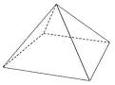 | Shape:______________________________  Label the radius, diameter, slant height and height.  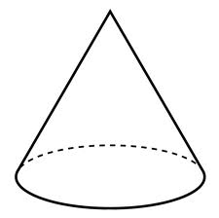
Shape:______________________________  Label the radius.  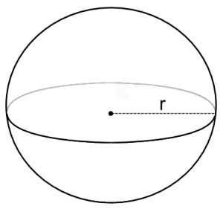 | Shape:______________________________  Label the length and width.
Shape:______________________________  Label the base and height. | Shape:______________________________  Label the base and height.
Shape:______________________________  Label the bases and height. | Shape:______________________________  Label the radius, diameter and circumference.

