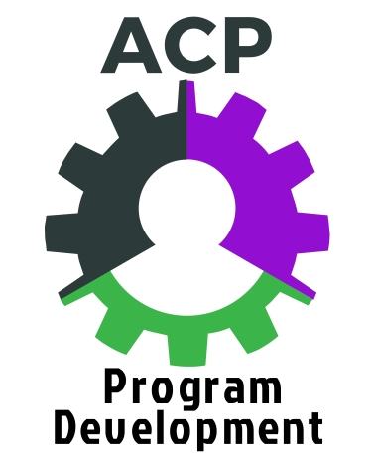
Assignment #3:
Local Workforce Development Plans – Worksheet
DUE DATES: Complete by August 14 and bring to August 15-16, 2017 workshop to discuss.
Post to Schoology by August 28 (typed in Word, or hand-written & scanned).
References:
Regional and local workforce development area map – http://mwca-mn.org/workforce_development_areas.htm
Regional and local workforce development plans – https://mn.gov/deed/gwdb/priorities/wioa/
Workforce Center Directory: https://mn.gov/deed/job-seekers/workforce-centers/workforce-center-locations/wfc-directory.jsp

- Name:

- ABE Consortium / Location:

- Regional Workforce Development Area (RWDA):

- Local Workforce Development Area (LWDA):

- Workforce Centers in your Local WDA:

- Do you have a relationship with your LWDA board? If so, describe. If not, why not?

- Had you previously read through your LWDA plan? In full or in part? How do you see its relevance to your adult career pathway decision-making and actions?

Read the LWDA plan and answer the following questions. Make a note of the page # where you found information, for easy reference later.
- Who is your ABE rep on the LWDB?

- Were you involved in any way in developing the LWDA plan? If so, how?

- Where / how does ABE show up in the plan? (You can use the Find (Ctrl-F) function to find all mentions of ABE in the online document.) List what you find.

  - Were you aware of ABE’s roles in the Plan? Any surprises?

- What career sectors have been identified as targets/priorities for adult career pathways in your LWDA?

  - Does your adult career pathway (your focus for this cohort) align with the Plan’s career sector priorities?

  - If not, how do you know that there is a need for your pathway program; i.e., how and why was it chosen?

- What populations have been identified in your LWDA as having barriers to employment, and thus priority populations for adult career pathway (ACP) programming?

  - How can you use this information to establish target or priority populations to serve with your ACP?

- What entities (agencies, institutions, etc.) are involved in career pathway programming in your LWDA?

  - Which of these entities are you already in relationship with in some way?

  - Which entities are new to you, that provide an opportunity for new institutional relationships in developing and delivering your ACP?

- What other important information did you find in the Plan?

- What questions do you have about the Plan?

- YOUR NEXT STEPS:

