Name:_________________________
Directions:
- Match each problem with the sketch it goes with.
- Draw your own sketch each for each problem.
  - Label your sketch with the information from the problem.
  - Write down the GED formula (from the formula sheet) that goes with the problem.
- BONUS - Solve each problem

- Match each problem with the sketch it goes with.

- A parallelogram has an area of 10b, where b = length of the base. What is the area of a triangle with the same height as the parallelogram, and a base length of 6 units?

- What is the surface area of a cylinder with a height of 64 inches and a diameter of 28 inches?

- A set of wooden toy blocks contains cubes, cylinders, and square-based pyramids. All of the blocks have a height of 2 inches. If no block is wider than it is tall, which of the three types of block has the largest volume?

- Maria has a circular rug with a 25-foot circumference and one with a 13-foot circumference. Of these rugs, which would be best to cover the floor of her square entry way that measures 5 feet along each side.

- Alejandro discovered that the dimensions of his yard are directly proportional to the dimensions of his laptop computer! If his laptop computer measures 10 by 12 inches and the width of his yard is 45 feet, what is the length of the yard?

- In one corner of Celia’s restaurant, she made a 15-square foot area for kids to play and look at books. The play area is in the shape of a right triangle; if one leg of the triangle is 5 feet long, what is the length of the other leg?

- Meg’s family spent 4 hours preparing the holiday dinner, but Anna’s family spent three hours less than twice that time! How many hours did Anna’s family spend preparing the dinner?

- Janae walks to work at 3 miles per hour. If she works 2 miles from her house, what time will Janae need to leave home so that she can get to work by 8:00 am?

- A box of a dozen coffee cups was originally priced at $10, but is now on sale for 15% off. At this sale price, what is the cost of one cup?

- Marco usually walks around the park to get to work. He walks four blocks east and then five blocks north. If he were to take a short cut by walking in a straight line through the park, about how many blocks would that be?
Problem the picture matches with: _____ | 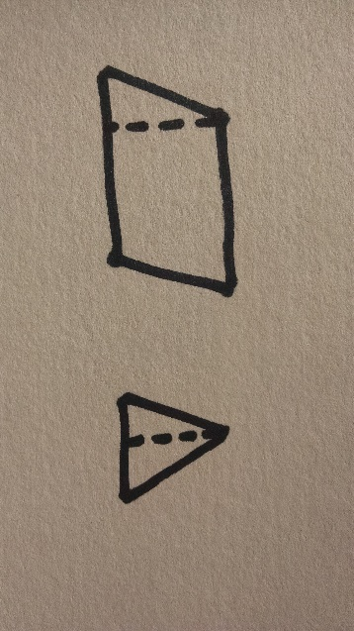  Problem the picture matches with: _____
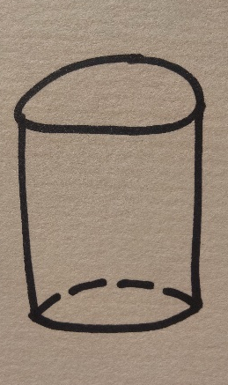  Problem the picture matches with: _____ | 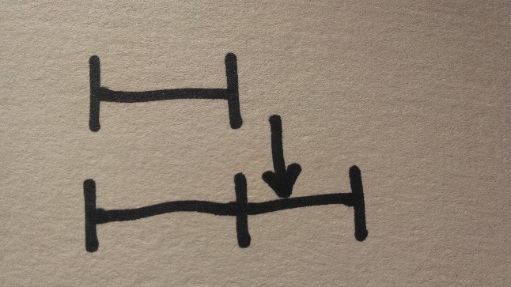  Problem the picture matches with: _____
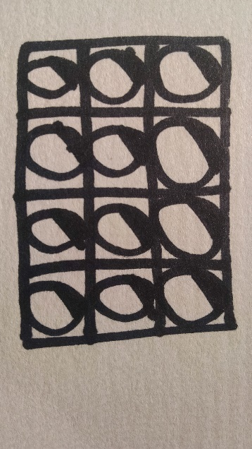  Problem the picture matches with: _____ | 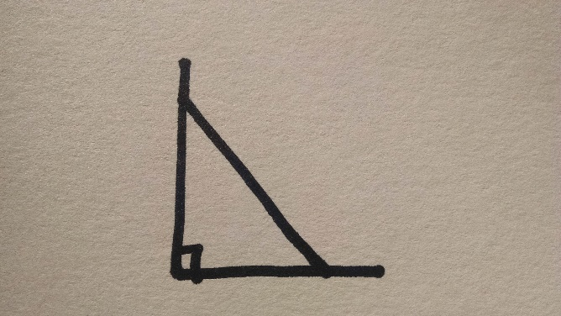  Problem the picture matches with: _____
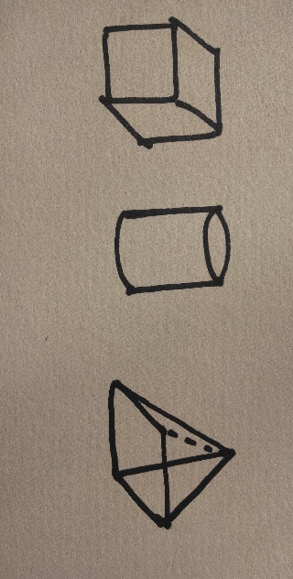  Problem the picture matches with: _____ | 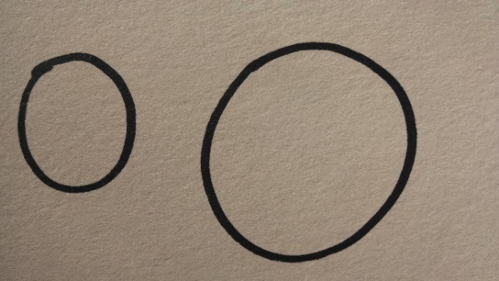  Problem the picture matches with: _____
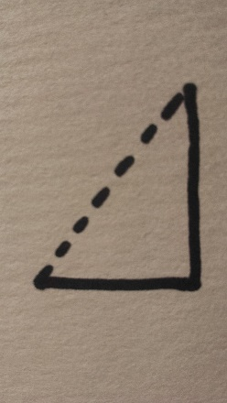  Problem the picture matches with: _____ | 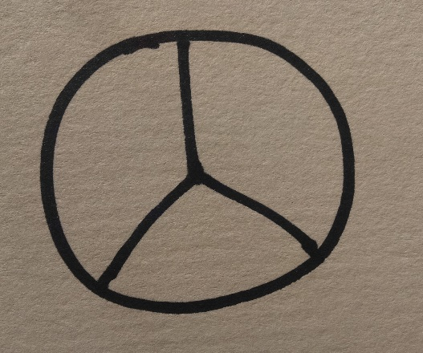  Problem the picture matches with: _____

- Draw your own sketch each for each problem.
  - Label your sketch with the information from the problem.
  - Write down the GED formula (from the formula sheet) that goes with the problem.

- A parallelogram has an area of 10b, where b = length of the base. What is the area of a triangle with the same height as the parallelogram, and a base length of 6 units? | My sketch with labels:  GED equation(s):
- What is the surface area of a cylinder with a height of 64 inches and a diameter of 28 inches? | My sketch with labels:  GED equation(s):
- A set of wooden toy blocks contains cubes, cylinders, and square-based pyramids. All of the blocks have a height of 2 inches. If no block is wider than it is tall, which of the three types of block has the largest volume? | My sketch with labels:  GED equation(s):
- Maria has a circular rug with a 25-foot circumference and one with a 13-foot circumference. Of these rugs, which would be best to cover the floor of her square entry way that measures 5 feet along each side. | My sketch with labels:  GED equation(s):
- Alejandro discovered that the dimensions of his yard are directly proportional to the dimensions of his laptop computer! If his laptop computer measures 10 by 12 inches and the width of his yard is 45 feet, what is the length of the yard? | My sketch with labels:  GED equation(s):
- In one corner of Celia’s restaurant, she made a 15-square foot area for kids to play and look at books. The play area is in the shape of a right triangle; if one leg of the triangle is 5 feet long, what is the length of the other leg? | My sketch with labels:  GED equation(s):
- Meg’s family spent 4 hours preparing the holiday dinner, but Anna’s family spent three hours less than twice that time! How many hours did Anna’s family spend preparing the dinner? | My sketch with labels:  GED equation(s):
- Janae walks to work at 3 miles per hour. If she works 2 miles from her house, what time will Janae need to leave home so that she can get to work by 8:00 am? | My sketch with labels:  GED equation(s):
- A box of a dozen coffee cups was originally priced at $10, but is now on sale for 15% off. At this sale price, what is the cost of one cup? | My sketch with labels:  GED equation(s):
- Marco usually walks around the park to get to work. He walks four blocks east and then five blocks north. If he were to take a short cut by walking in a straight line through the park, about how many blocks would that be? | My sketch with labels:  GED equation(s):

C. BONUS - Solve each problem
Show your work above, below or on a separate sheet of paper.

