Name: _________________________________________________________

Version B

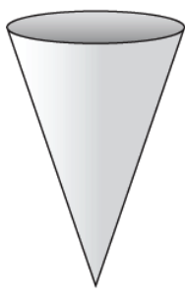
A company makes filters in the shape shown. Each filter is 3 ¼ inches wide at the top and holds up to 8.3 cubic inches of liquid inside. To the nearest tenth of an inch, what is the surface area of the smallest rectangular box that could contain the filter?

Directions:
Try to solve the problem. You can use the GED formula sheet and a calculator. Then answer the questions below.

- What did you do first?

- How did you decide?

- If you were able to solve the problem describe what steps you used. ---OR--- If you are stuck, describe the steps you tried.

- What was confusing about this problem?

Name: _____________________________________________________________

Version A

A factory makes filters the shape shown. Each filter is 3 ¼ inches wide at the top and holds 8.3 cubic inches of liquid. To the nearest tenth of an inch, what is the height of the filter?

Directions:
Try to solve the problem. You can use the GED formula sheet and a calculator. Then answer the questions below.

- What did you do first?

- How did you decide?

- If you were able to solve the problem describe what steps you used. ---OR--- If you are stuck, describe the steps you tried.

- What was confusing about this problem?

