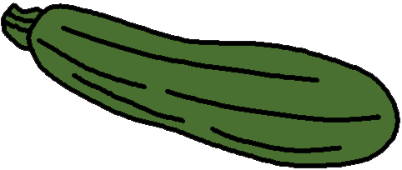**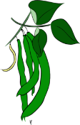What vegetables are in the garden?**

|  |  |
| --- | --- |
| Vegetable name | Picture |
|  |  |
|  |  |
|  |  |
|  |  |
|  |  |
|  |  |