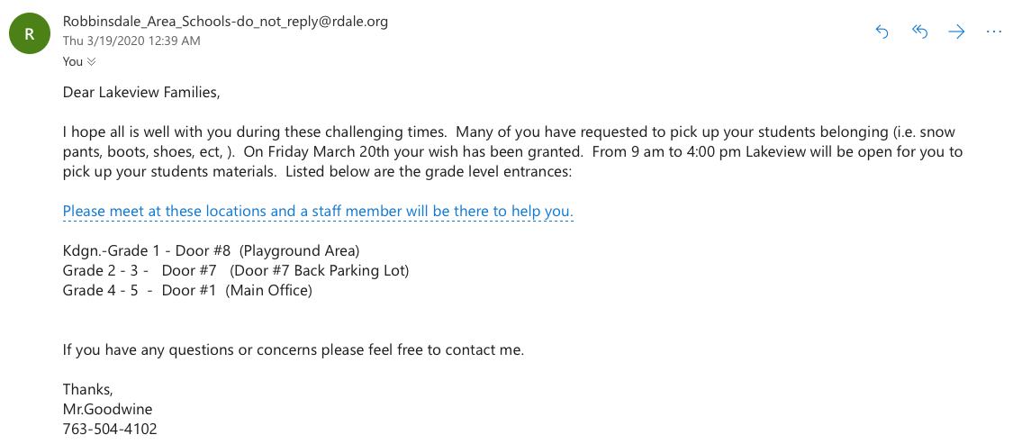
Directions: Read the e-mail. Answer the questions.

Comprehension Questions
- Why did Mr. Goodwine write this e-mail?
- When can families go to pick up student belongings?
- What is the meaning of the word belonging, as it is used in this text?
- If your child is in 3rd grade, what door would you go to?
- What number should you call if you have questions?

Writing Practice
After reading this e-mail, what is one question that you think a parent might have? Write an e-mail response that asks a question.

