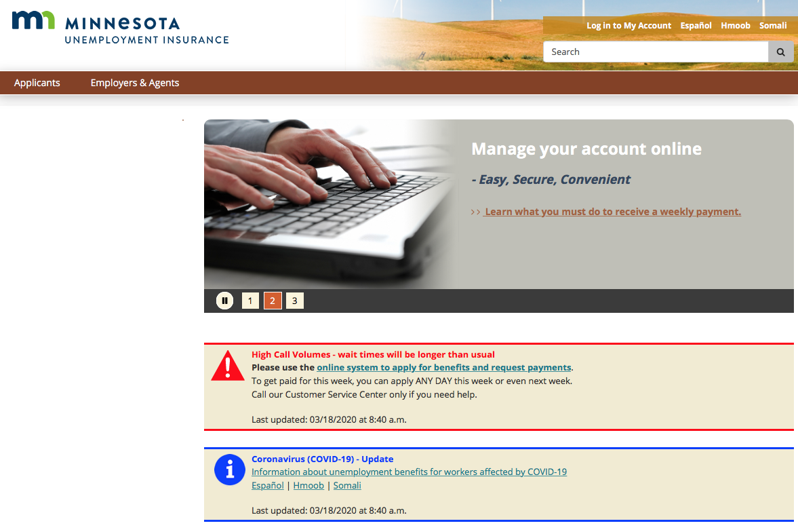
Directions: Read the information from a website. Answer the questions.

Comprehension Questions
- What is the most likely reason that someone would visit this website?
- What does the phrase “High Call Volumes” mean? What should people do because of the high call volumes?
- What is the meaning of the word volume, as it is used in this text?
- When was the information on this website last updated?
- If you want to get paid for this week, when can you apply?
- Why is there a picture of hands and a keyboard? How does this picture contribute to your understanding of this text?
- Who is providing the information that is available on this website?

Writing Practice
Imagine you have a friend who needs to apply for unemployment benefits, but isn’t sure how to do it. What are two pieces of advice that you would give to your friend?

