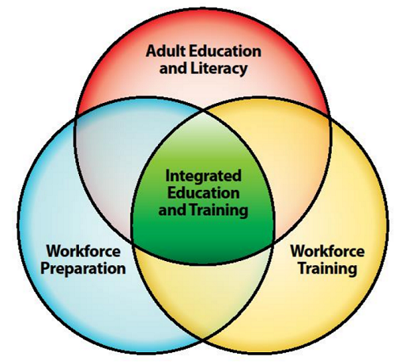
Application for Participation in the 2022-2023
IET Academy

I. ABE Provider Information

ABE Provider Organization Name
ABE Provider Address
IET Academy Team Lead Person

Please respond to the following questions in one to two paragraphs each. We will select participants based on your responses to the following questions, so please answer thoughtfully and thoroughly!

1. Does your program currently offer any adult career pathways (ACP) or Integrated Education and Training (IET) programming? If so, please describe.

2. Describe any previous experience you might have providing adult career pathways (ACP) or Integrated Education and Training (IET) instruction.

3. Please describe the class(es)/context in which you plan to implement this training, including:

Career cluster or occupation
Culminating postsecondary credential of career pathway
Training partner(s) and/or Employer partner(s), and support services
Type of enrollment system (managed or open)
Type of delivery model (in-person, online, hybrid, hyflex, TVM)
Total number of weeks and hours of class/course

5. Please describe the target students (educational functioning levels, language backgrounds, career goals) for your proposed IET program.

6. When do you plan to implement the class/course developed as part of this training?

7. Please explain why your program would like to participate in this professional development and what you hope to learn through your participation.

8. (Optional) Any questions for us?

II. Team Members
At a minimum, participating teams should consist of the ABE administrator overseeing the planned IET program and the ABE teachers(s) involved in IET delivery.
For each participant, please copy and complete this table below:
Name
Email
Phone number
Role (administrator, teacher, etc.)

III. Requirements for Participation
(Please mark an “X” in front of each of the 3 requirements)

- ____ I understand that if accepted to participate in the IET Academy, our team members commit to the following:

Date | Event/Activity | Location
June 24, 2022 | Applications Due | Online - email Heather Turngren
June 30, 2022 | Notification of Acceptance | Via Email
August 9 - September 9, 2022 | Initial meeting w/ ATLAS/MDE staff and self-assessment | Virtual and Online  (~3 hrs)
September 13, 2022  9:00am - 3:00pm | IET Academy Kickoff Workshop  (This activity includes instructors and managers.)  (hotel & mileage reimbursed for those traveling 100 miles or more round trip) | In-person  Twin Cities Metro area, details TBD  (~6 hrs)
September 14 - December 22, 2022 | Virtual Community of Practice  (approximately 30 minutes every 2 weeks) | Online – Mighty Network  (8 posts x 30 min = ~4 hrs)
September 14 - December 22, 2022 | Coaching:  SSLO Development for Instructors  IET Design Toolkit Task for Managers  (Two-three 1-hour calls per participant or small groups) | Online/Phone  (~2-3 hours)
September 14 - December 22, 2022 | IET Design Toolkit Tasks  (determined from self-assessment) | At your program
December 6, 2022  12:30pm - 4:30pm | Culminating Workshop  (This activity includes instructors and managers.) | Virtual  (~4 hrs)  total time = ~20hrs)

- ____I understand that each team member will receive a $300 stipend only upon completion of all of the IET Academy components above.

- ____I understand that participating programs are expected to actively be planning for or delivering IET during the FY23 program year.

To Submit Your Application
Please type directly into this document, save it on your computer, and then email it to Heather Turngren at heather.turngren@mpls.k12.mn.us.
Questions about the content of this professional development activity should be directed to Heather Turngren at heather.turngren@mpls.k12.mn.us.
Deadline for applications: June 24, 2022
Applicants will be notified of their acceptance by June 30, 2022.

